Q.) Consider a table pizzaSales with columns order_id and order_date. Write an SQL query that generates a report showing the total number of orders for each day of the week. The report should be sorted by the day_countin in ascending/descending order. (like Sunday-Monday-Tuesday-Wednesday and so-on)

Step 1st :

The to_char() function is used in SQL to convert a value to a specific character string format. It's commonly used for formatting date and time values, but it can also be used to format other types of data.

select to_char(order_date, 'DAY') as day_of_week,

count(order_id) from pizzaSales

group by day_of_week;

Output:

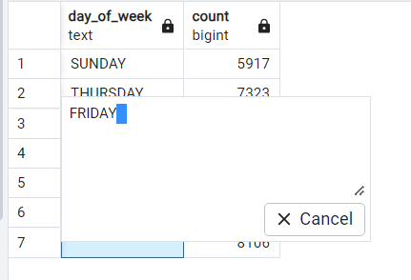

Here, I am getting spaces in day_of_week

Step 2nd :

select trim(both ' ' from to_char(order_date,'DAY')) as day_of_week,

count(order_id)

from pizzaSales

group by day_of_week;

Output:

as I am getting spaces in day_of_week, so I used trim() to remove these spaces and ordered them in ascending/descending order.

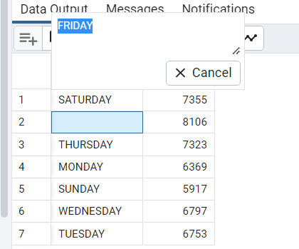

Step 3rd :

select trim(both ' ' from to_char(order_date,'DAY')) as day_of_week,

case when trim(both ' ' from to_char(order_date,'DAY'))='SUNDAY' THEN 1

WHEN trim(both ' ' from to_char(order_date,'DAY'))='MONDAY' THEN 2

WHEN trim(both ' ' from to_char(order_date,'DAY'))='TUESDAY' THEN 3

WHEN trim(both ' ' from to_char(order_date,'DAY'))='WEDNESDAY' THEN 4

WHEN trim(both ' ' from to_char(order_date,'DAY'))='THURSDAY' THEN 5

WHEN trim(both ' ' from to_char(order_date,'DAY'))='FRIDAY' THEN 6

WHEN trim(both ' ' from to_char(order_date,'DAY'))='SATURDAY' THEN 7

END AS day_counting,

count(order_id) from pizzaSales

group by day_of_week,day_counting

order by day_counting;

Output:

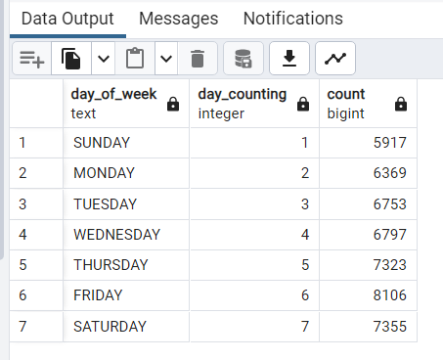

Another simple way to get the same output without using trim()

SELECT TO_CHAR(order_date, 'DAY') AS day_of_week,

CASE

WHEN EXTRACT(DOW FROM order_date) = 0 THEN 1 -- Sunday

WHEN EXTRACT(DOW FROM order_date) = 1 THEN 2 -- Monday

WHEN EXTRACT(DOW FROM order_date) = 2 THEN 3 -- Tuesday

WHEN EXTRACT(DOW FROM order_date) = 3 THEN 4 -- Wednesday

WHEN EXTRACT(DOW FROM order_date) = 4 THEN 5 -- Thursday

WHEN EXTRACT(DOW FROM order_date) = 5 THEN 6 -- Friday

WHEN EXTRACT(DOW FROM order_date) = 6 THEN 7 -- Saturday

END AS day_counting,

COUNT(order_id) AS total_orders

FROM pizzaSales

GROUP BY day_of_week, day_counting

ORDER BY day_counting;

Output:

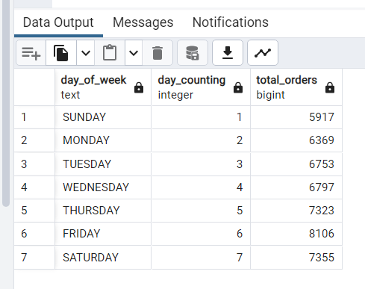

DOW - Day of the Week..

The EXTRACT function in SQL is used to retrieve specific parts (such as year, month, day, hour, etc.) from a date or time value. It provides a way to break down a datetime value into its individual components.

SELECT EXTRACT((YEAR/MONTH/DAY) FROM ’23-04-1997’);